OSSP PRACTICAL _ 4

Task-1 Write a C program where a parent process creates multiple child processes and synchronizes their completion using wait() and waitpid(). Compare the behavior of both functions
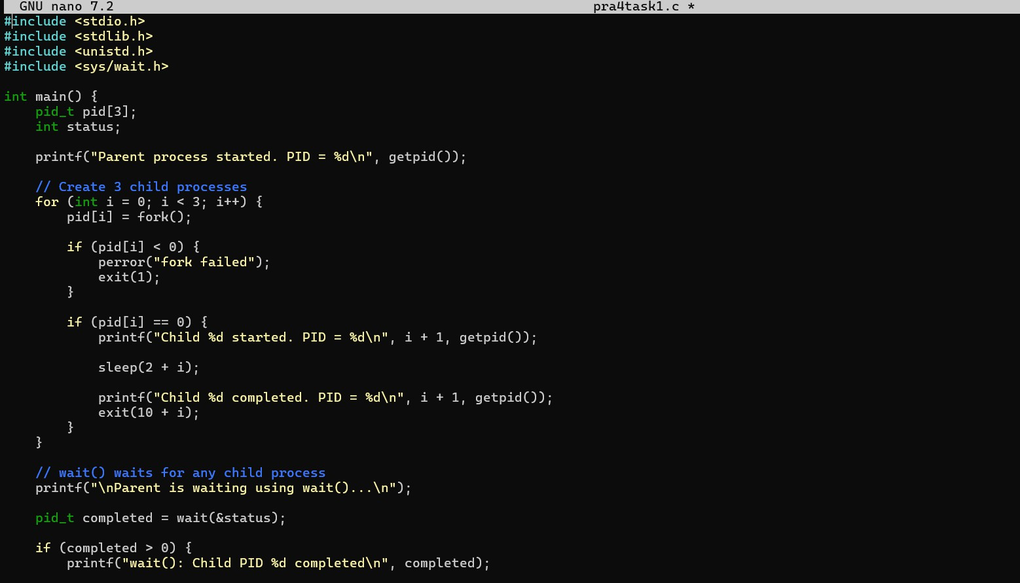
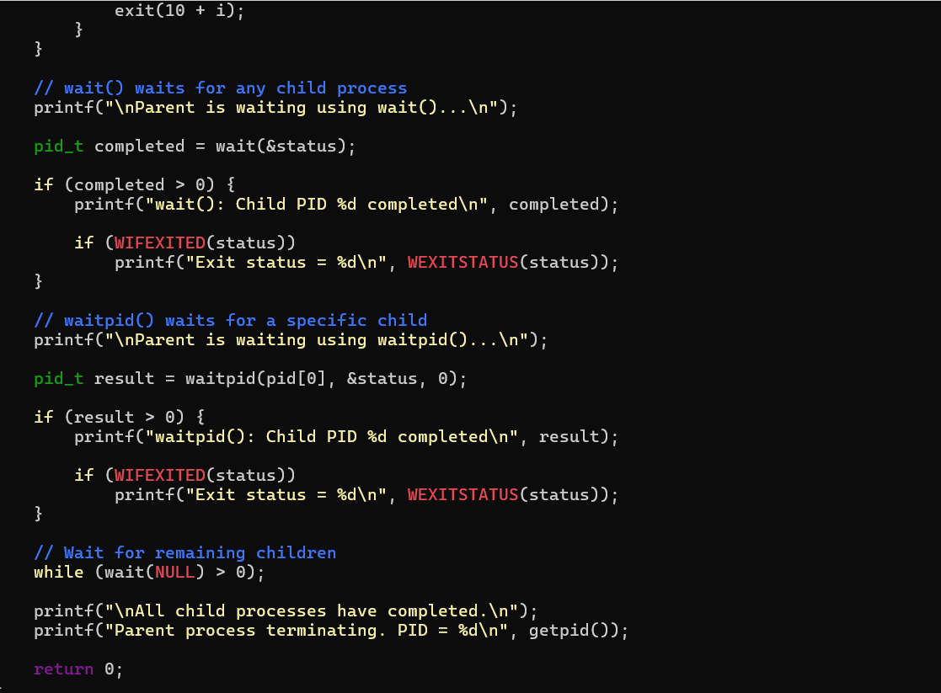

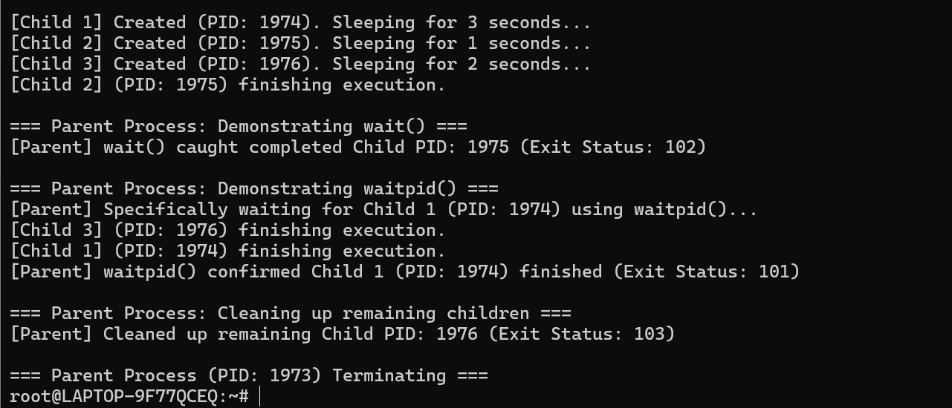

Observation
- The parent process successfully created three child processes using
fork().
- Each child process executed independently and terminated after a different delay.
- The wait() function waited for any one child process to complete and returned the PID of the completed child.
- The waitpid() function waited for a specific child process using its PID.
- The parent process synchronized with all child processes before terminating.
- Thus, wait() provides general child-process synchronization, while waitpid() provides more specific control over which child process is waited for.

Task-2 Create a scenario where a child process becomes a zombie process. Investigate the process table and then modify the program to eliminate zombie processes using proper synchronization techniques.
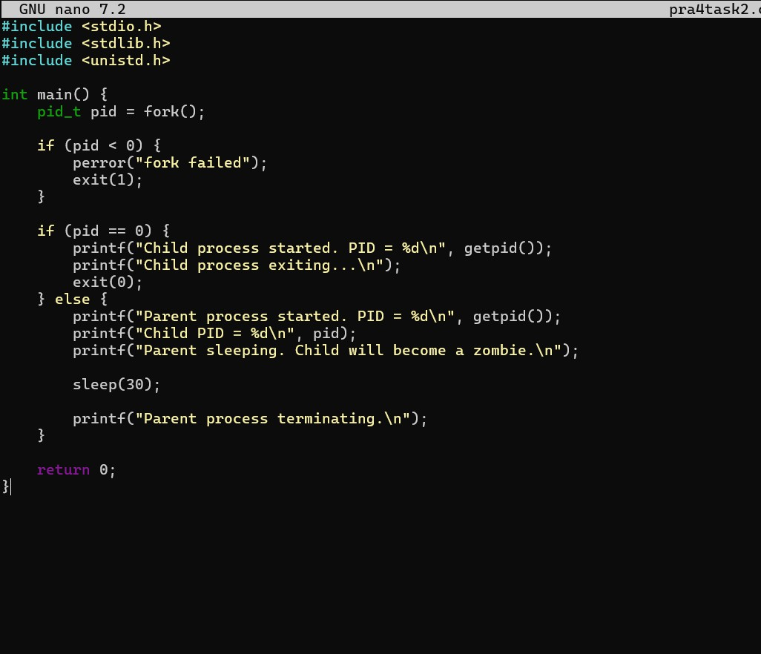

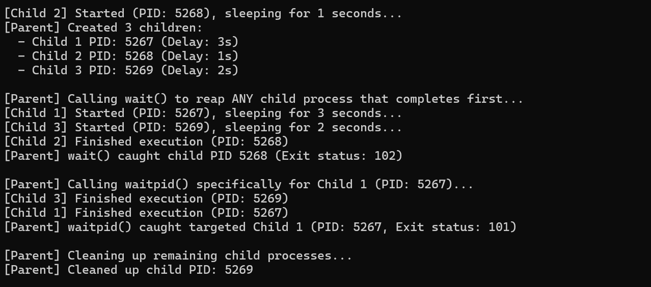

Observation
- A child process was created using fork().
- The child terminated while the parent continued executing without calling wait() or waitpid().
- The terminated child remained in the process table as a zombie (Z) /
<defunct> process because its exit status had not been collected by the parent.
- The program was then modified to use waitpid() for proper synchronization.
- After the modification, the parent collected the child's exit status immediately after its termination.
- The child was therefore removed from the process table and no zombie process was created.
- This demonstrates that proper parent-child synchronization using
wait() or waitpid() prevents zombie processes.

